Homework3

**Number：2017329621139 Name：徐政辉 class：17计科全英文**

**5. Answer questions (a)–(g) for the graph defined by the following sets:**

**N = {1, 2, 3, 4, 5, 6, 7}**

**N0 = {1}**

**Nf = {7}**

**E = {(1, 2),(1, 7),(2, 3),(2, 4),(3, 2),(4, 5),(4, 6),(5, 6),(6, 1)}**

**Also consider the following (candidate) test paths:**

**t0 = [1, 2, 4, 5, 6, 1, 7] t1 = [1, 2, 3, 2, 4, 6, 1, 7]**

1. **Draw the graph.**

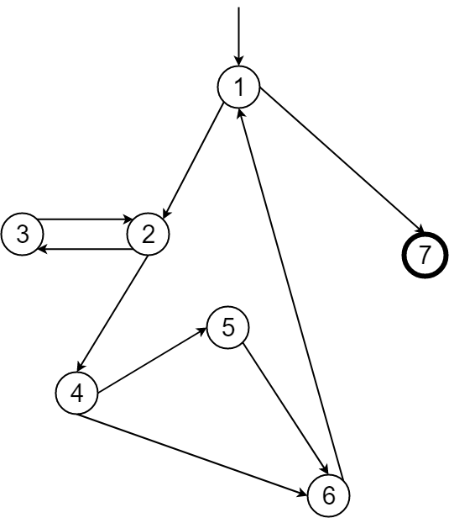

1. **List the test requirements for edge-pair coverage. (Hint: You should get 12 requirements of length 2).**

TR = {[1,2,3], [1,2,4], [2,3,2], [3,2,4], [3,2,3], [2,4,5], [2,4,6], [4,5,6], [4,6,1], [5,6,1], [6,1,7], [6,1,2]}

1. **Does the given set of test paths satisfy edge-pair coverage? If not, identify what is missing.**

No.

Missing edge-pair coverage = {[3,2,3], [6,1,2]}

1. **Consider the simple path [3, 2, 4, 5, 6] and test path [1, 2, 3, 2, 4, 6, 1, 2, 4, 5, 6, 1, 7]. Does the test path tour the simple path directly? With a sidetrip? If so, identify the sidetrip.**

No.

Sidetrip = [6,1,2,4]

1. **List the test requirements for node coverage, edge coverage, and prime path coverage on the graph.**

Node coverage TR = {[1,2,3,2,4,5,6,1,7]}

Edge coverage TR = {[1,2,3,2,4,5,6,1,7], [1,2,4,6,1,7]}

Prime path coverage TR = {[1,2,3,2], [1,2,4,5,6,1,7], [1,2,4,6,1,7], [3,2,4,5,6,1,7], [2,4,5,6,1,2], [4,5,6,1,2,3], [4,5,6,1,2,4], [4,6,1,2,3], [4,6,1,2,4], [5,6,1,2,4,5], [6,1,2,4,6]}

Note:

A path is prime if it is simple and does not appear as a proper subpath of any other simple path.

Prime Path Coverage [PPC]: TR contains each prime path in G.

A path is simple if no node appears more than once in the path, except that the first and last nodes may be the same.

1. **List test paths that achieve node coverage but not edge coverage on the graph.**

Test paths = {[1,2,3,2,4,5,6,1,7]}

1. **List test paths that achieve edge coverage but not prime path coverage on the graph.**

Test paths = {[1,2,4,6,1,2,3,2,4,5,6,1,7], [1,2,3,2,4,5,6,1,2,4,6,1,7], [1,2,3,2,4,6,1,2,4,5,6,1,7], [1,2,4,5,6,1,2,3,2,4,6,1,7]}